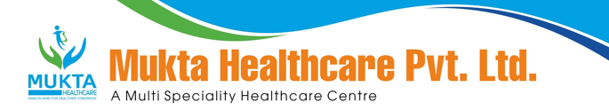

MONTHLY BIO-MEDICAL WASTE REPORT
For the Month of January,2024

- Name of the Health Care Unit: Mukta Nursing Home
- Address: Medical More, Sarada pally, Shiv Mandir, Siliguri 734011, Contact No: 9733533535
- Category-wise (As per Schedule of the Rule) generated and quantity for the month of January, 2024.

Category | Count(Bags) | Waste Quantity(Kg)
YELLOW | 41 | 98.2
RED | 18 | 35.1
1WHITE(Sharp) | 1 | 2.5
Blue(Glass) | 1 | 4.5

- Category-wise total quantity of waste sent to common BMW treatment facility.
  - Incineration/Burial (yellow bags):98.2Kg.(Own facility/Common BMW treatment
facility)
  - Autoclave/Microwave:
(a)Red Bag:35.1Kg (Own facility/Common BMW treatment facility}
(b)Sharp Container2.5kg.(Own facility/Common BMW treatment facility)

- Any other relevant information.

- Certified that the above report is for the month of January,2024.

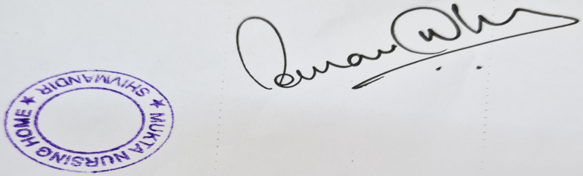

Dr Sourav Dhar
Managing Director

