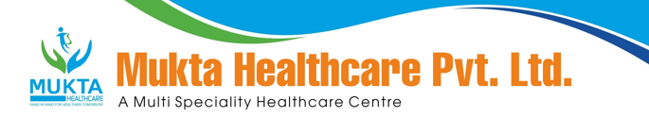

MONTHLY BIO-MEDICAL WASTE REPORT
For the Month of May,2024

- Name of the Health Care Unit: Mukta Nursing Home
- Address: Medical More, Sarada pally, Shiv Mandir, Siliguri 734011, Contact No: 9733533535
- Category-wise (As per Schedule of the Rule) generated and quantity for the month of May, 2024.

Category | Count(Bags) | Waste Quantity(Kg)
YELLOW | 78 | 143.90
RED | 68 | 116.00
1WHITE(Sharp) | 4 | 1.90
Blue(Glass) | 1 | 6.00

- Category-wise total quantity of waste sent to common BMW treatment facility.
  - Incineration/Burial (yellow bags):143.90Kg.(Own facility/Common BMW treatment
facility)
  - Auto clave/Microwave:
(a)Red Bag: 116.00Kg(Own facility/Common BMW treatment facility}
(b)Sharp Container 1.90kg.(Own facility/Common BMW treatment facility)

- Any other relevant information.

- Certified that the above report is for the month of May,2024.

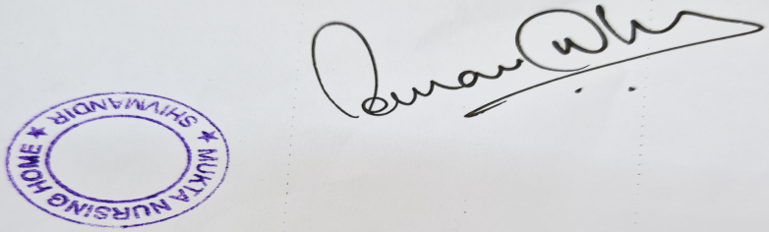

Dr Sourav Dhar
Managing Director

