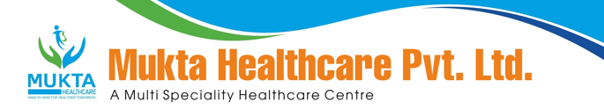

MONTHLY BIO-MEDICAL WASTE REPORT
For the Month of June,2025

- Name of the Health Care Unit: Mukta Nursing Home
- Address: Medical More, Sarada pally, Shiv Mandir, Siliguri 734011, Contact No: 9733533535
- Category-wise (As per Schedule of the Rule) generated and quantity for the month of June,2025.

Category | Count(Bags) | Waste Quantity(Kg)
YELLOW | 62 | 105.50
RED | 52 | 85.0
WHITE(Sharp) | 1 | 3.00
Blue(Glass) | 2 | 7.00

- Category-wise total quantity of waste sent to common BMW treatment facility.
  - Incineration/Burial (yellow bags):105.50 Kg.(Own facility/Common BMW treatment
facility)
  - Auto clave/Microwave:
(a)Red Bag: 85.00 Kg(Own facility/Common BMW treatment facility}
(b)Sharp Container 3.00 kg.(Own facility/Common BMW treatment facility)

- Any other relevant information.

- Certified that the above report is for the month of June,2025.

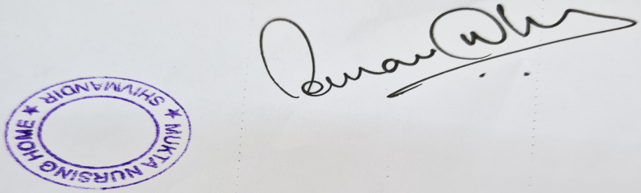

Dr Sourav Dhar
Managing Director

